ARMA模型预测，为了保证平稳性先用seasonal_decompose函数将时间序列拆分为trend

，seasonal，residual，分别对其进行ARMA建模，确定p，q，得到预测值后再进行相加得到最终的预测结果。

在下面实验中，p，q的取值分别为：

Trend 1,0

Seasonal 4,0

Residual 1,0

滚动预测201506-201608，滑动窗口为1，每次训练数据为当前需预测月份之前的所有数据，每次预测一个月。

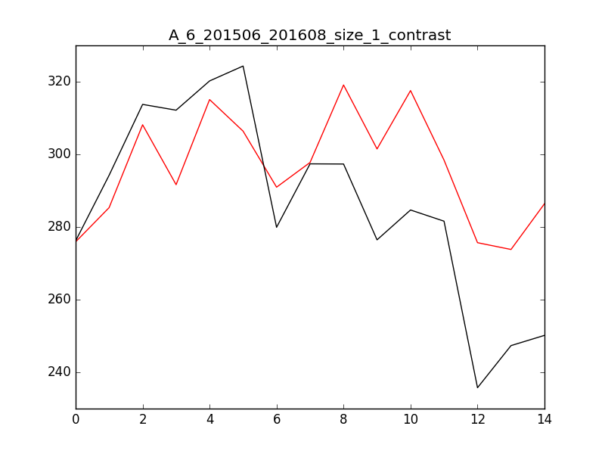

红色为预测值，黑色为实际值，具体数据如下：

201506: 275.909995698 276.170014415

201507: 285.3329668 294.244397834

201508: 308.144934843 313.75617244

201509: 291.656600332 312.164223568

201510: 315.082101957 320.216716155

201511: 306.393355311 324.318952813

201512: 290.965241193 279.918411946

201601: 297.767004082 297.387040044

201602: 319.10298724 297.338653353

201603: 301.491311969 276.461195778

201604: 317.560744601 284.684699341

201605: 298.426977645 281.602107366

201606: 275.680526814 235.751433269

201607: 273.813836018 247.345597846

201608: 286.413355988 250.163619758

滚动预测201506-201608，滑动窗口为3，每次训练数据为当前需预测月份之前的所有数据，每次预测3个月。

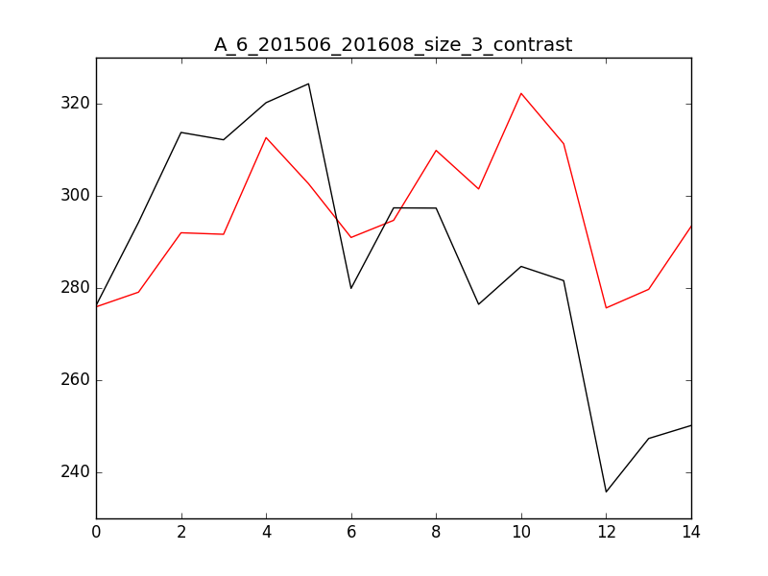

红色为预测值，黑色为实际值，具体数据如下：

201506: 275.909990914 276.170014415

201507: 279.097915112 294.244397834

201508: 291.985323753 313.75617244

201509: 291.656600332 312.164223568

201510: 312.641752075 320.216716155

201511: 302.621287467 324.318952813

201512: 290.965241193 279.918411946

201601: 294.686018759 297.387040044

201602: 309.854514256 297.338653353

201603: 301.491311969 276.461195778

201604: 322.238833473 284.684699341

201605: 311.318130735 281.602107366

201606: 275.680526814 235.751433269

201607: 279.710580616 247.345597846

201608: 293.380912873 250.163619758

方法同上，模型参数不变：

预测201609-201612数据：

260.829766688

282.018280103

271.005988899

248.769552859

方法同上，将模型参数改为：

Trend 3,0

Seasonal 5,0

Residual 1,1

预测201609-201612数据：

238.182136786

246.098104359

249.222068813

208.11087592